

Arvind Pal

Arvind.pal@itcinfotech.com

ZEAS

ZEAS –Audit Logs

**ZEAS –Audit Logs**

|  |  |  |  |  |
| --- | --- | --- | --- | --- |
| Version | Date | Created by | Reviewed by | Changes |
| 1.0.0 | 8/12/2016 | Arvind Singh Pal |  |  |
|  |  |  |  |  |
|  |  |  |  |  |

Table of Contents

Introduction 3

Pre-requisites 3

Business Requirements 3

Existing functionality 3

Proposed functionality 3

Detailed functionality 4

Assumptions and Risks 5

# 

# Introduction

ZEAS is ETL tool which provide single platform for data lack, Ingestion and data transformation, it provides data connection which supports large range of data-sources formats such as

RDBMS – MYSQL, Oracle and DB2

Files - CSV, XLS, JSON, XML, Fixed width delimiter etc.

# Pre-requisites

ZEAS should be running in any one Hadoop distributed enlivenments (Apache Hadoop or HDP) with below Hadoop services-

* Hive
* Sqoop
* Oozie

# Business Requirements

ZEAS Admin can download Audit logs from dashboard, logs will have all operational information performed through ZEAS.

# Existing functionality

ZEAS stores information into log files whose location is configurable. No download load option.

# Proposed functionality

Audit log means below information’s need to record:

* Profile creation date and time and created by.
* Ingestion performed date and time.
* Ingestion HDFS output location.
* Hive Table and Hive View information for Ingestion.
* Scheduler information.
* For Event Based scheduler : events triggered on folder ( File arrival Time, Ingestion trigger time)
* Input file final moved location after Ingestion completed.
* User Management Information

## Detailed functionality

1. Give Audit Download option to download logs in client machine , on click on icon display date range

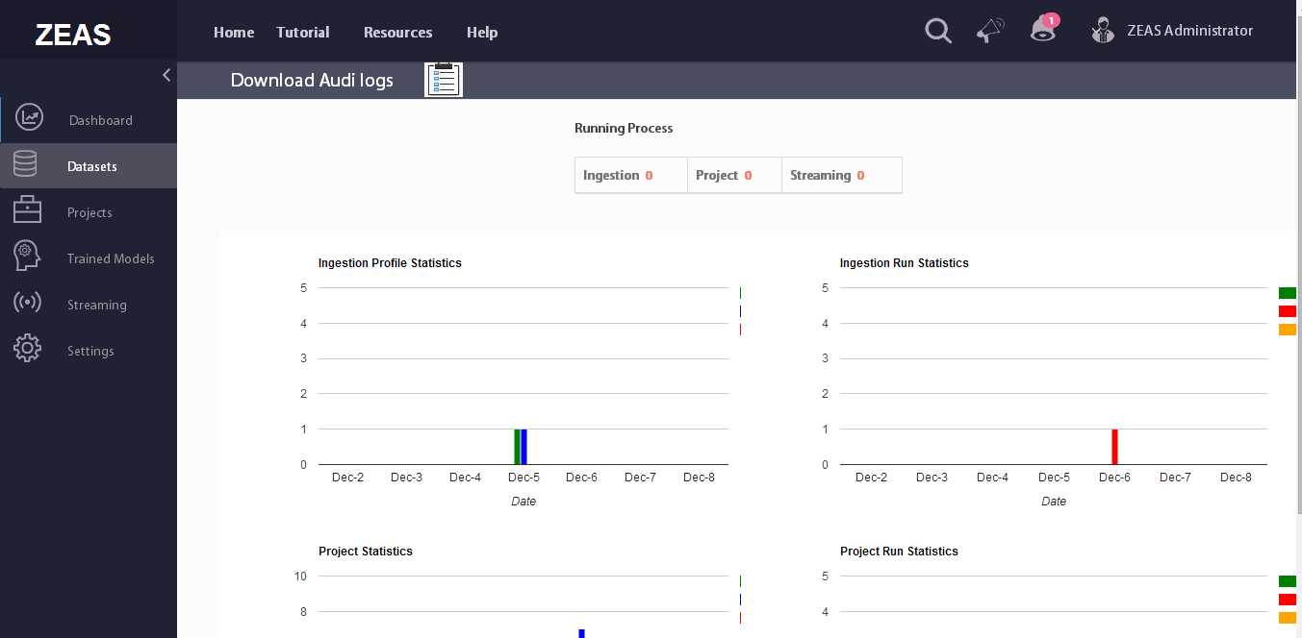

Screen -1

# Assumptions and Risks

1. Lack of dedicated resources.
2. No UI Developer
3. In case any requirement change the delivery time line will be impacted.